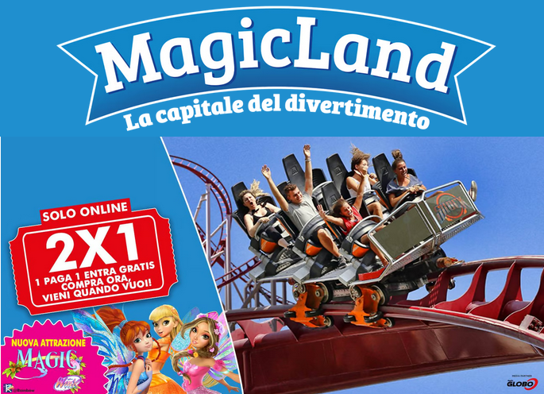
Dal 12 aprile torneranno il divertimento, l'adrenalina e l'emozione con una novità che sarà a dir poco FATALOSA! 🧚‍♀️
40 emozionanti attrazioni, spettacoli ed eventi ti faranno vivere incredibili avventure insieme ai tuoi amici!
Prima novità assoluta è la spettacolare attrazione Magic Winx, con il ritorno a MagicLand del Winx Club.

MA NON FINISCE QUI!

La nuova stagione prevede un ricco calendario di eventi estivi con il ritorno dei dj set e delle serate con special guest d’eccezione tra cui Cristina d’Avena, Paolo Noise, Dino Brown e Pippo Palmieri.
Non mancherà il Magic Fire Festival, l’appuntamento più atteso dell’estate, l'Oktober Festival, la grande festa di Halloween e,
per concludere, Magic Christmas, l’evento dedicato al Natale.
Tornano, inoltre, gli spettacoli sul lago con la celebre compagnia teatrale Les Farfadais che, tra acrobazie aeree, giochi di luce e video mapping, renderanno indimenticabili le sere d'estate nel Parco.

CON LA PROMO 2X1 DI MAGICLAND
1 paga 1 entra gratis!

Approfitta della promozione e ottieni subito i tuoi 2 biglietti
validi per tutta la stagione 2025!
Compra Ora, Vieni Quando Vuoi:
divertimento, emozione e adrenalina ti aspettano.

Clicca su:
https://magicland.it/it/shop/promo-magicfun?utm_source=ActiveCampaign&utm_medium=email&utm_content=Una%20nuova%20stagione%20di%20divertimento%20in%20arrivo%21&utm_campaign=NL_2x1&vgo_ee=iRXKzs7U7XXr3vsrJbOWjJHBWBpx6ajM%2FiUJ0O4b%2F8ksAcpYBeo4Y8gSOcog%3A9%2Fr0RerXfG8XqWO8sceBrMAC07QKdq6f

